### **Multi-Branch Project**

#### **Project Overview**

* Create a simple Java Maven project.
* Version-control the project using Git with multiple branches.
* Set up Jenkins multi-branch pipeline for automated build and deployment.
* Utilize Jenkins environment variables in the Jenkinsfile.

#### **Project Objectives**

* Version-control using Git.
* Jenkins multi-branch pipeline setup.
* Environment variable management using Jenkinsfile.

#### **Project Deliverables**

1. **Git Repository:**
   * Local Git repository initialized.
   * Branches: development, staging, and production.
   * Repository pushed to remote Git server (e.g., GitHub, GitLab, Bitbucket).
2. **Maven Project:**
   * Simple Java Maven project created (HelloWorld application).
   * pom.xml with dependencies and build configurations.
3. **Jenkins Setup:**
   * Multi-branch pipeline job configured in Jenkins.
   * Jenkinsfile defining build and deployment steps.
   * Environment variables managed using Jenkins environment variable settings.

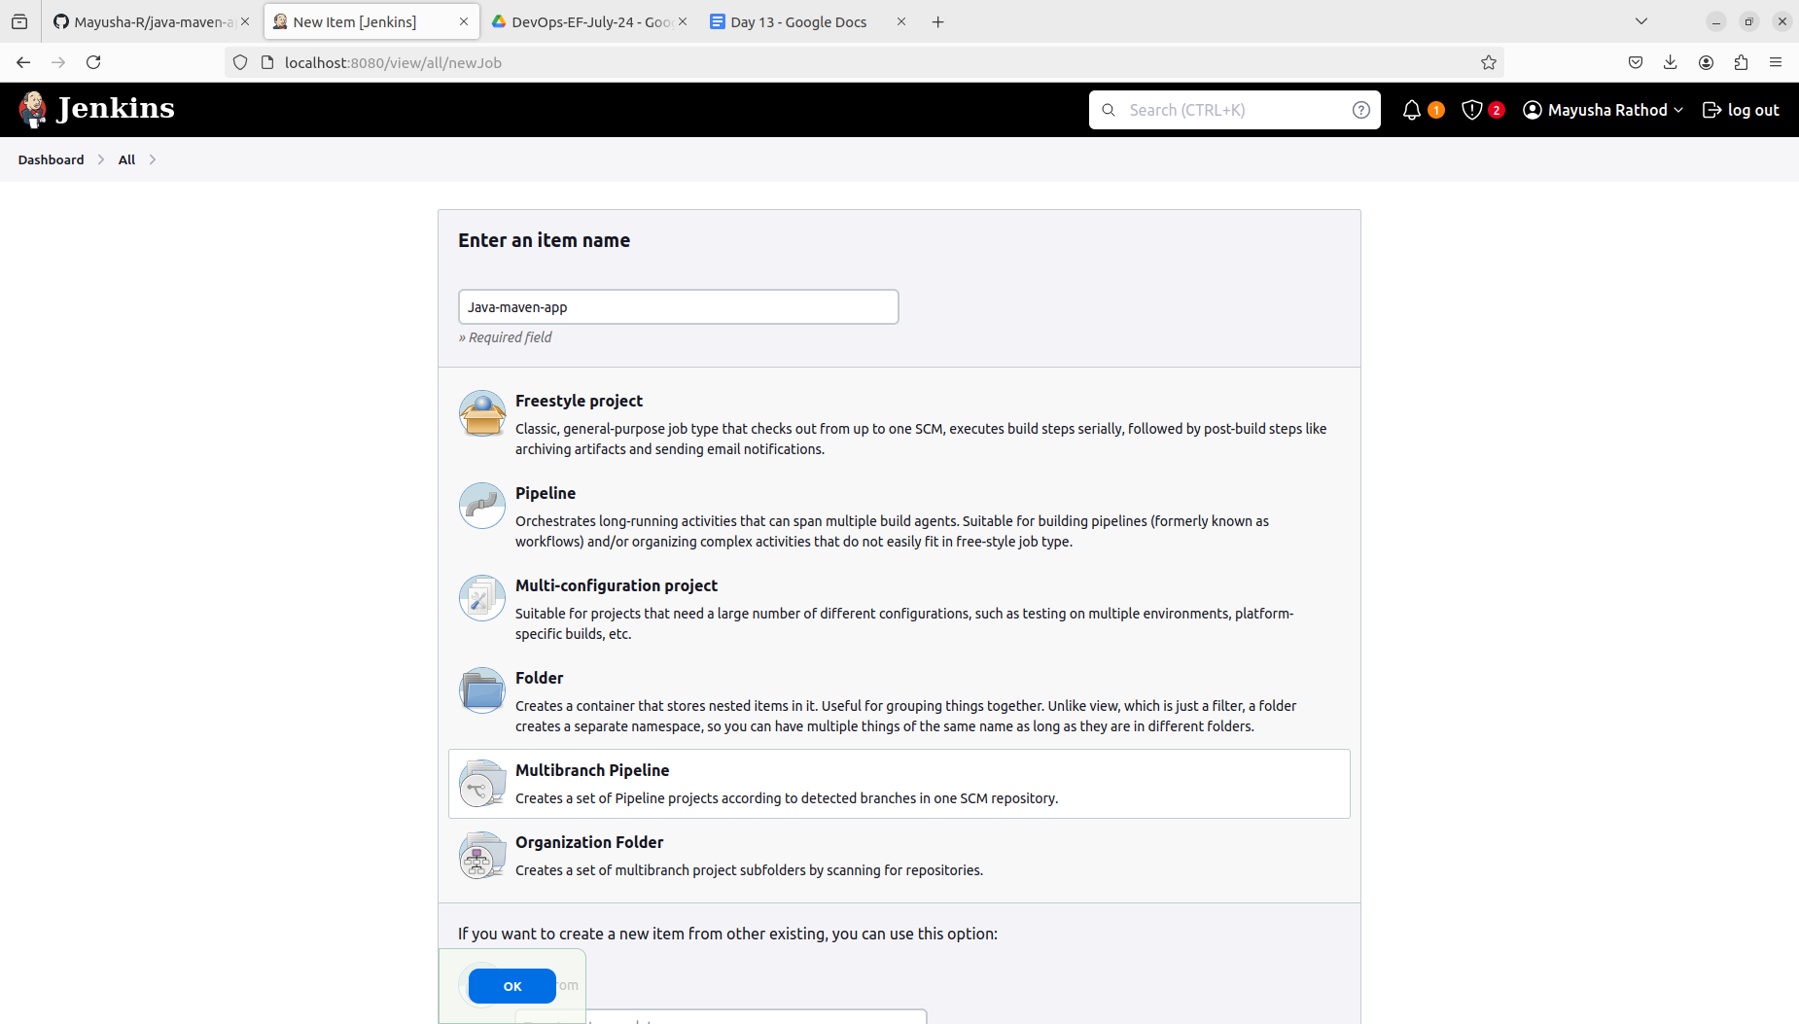

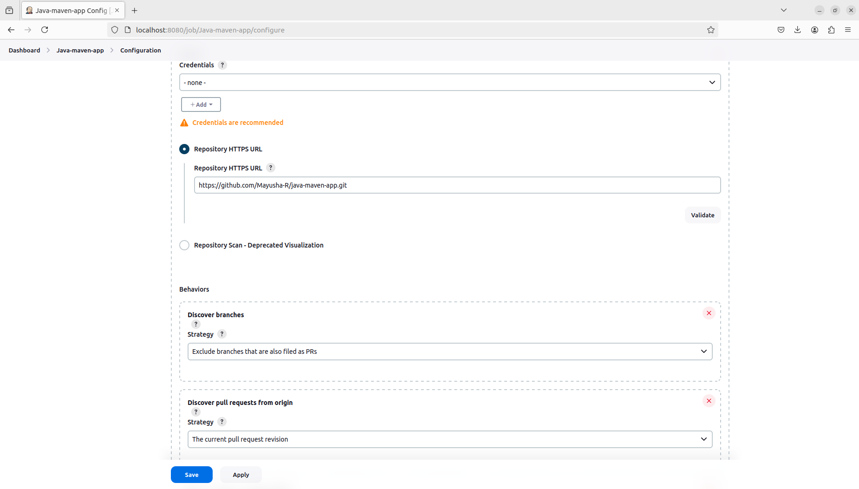

### Jenkinsfile in main and newbranch02 not in newbranch01

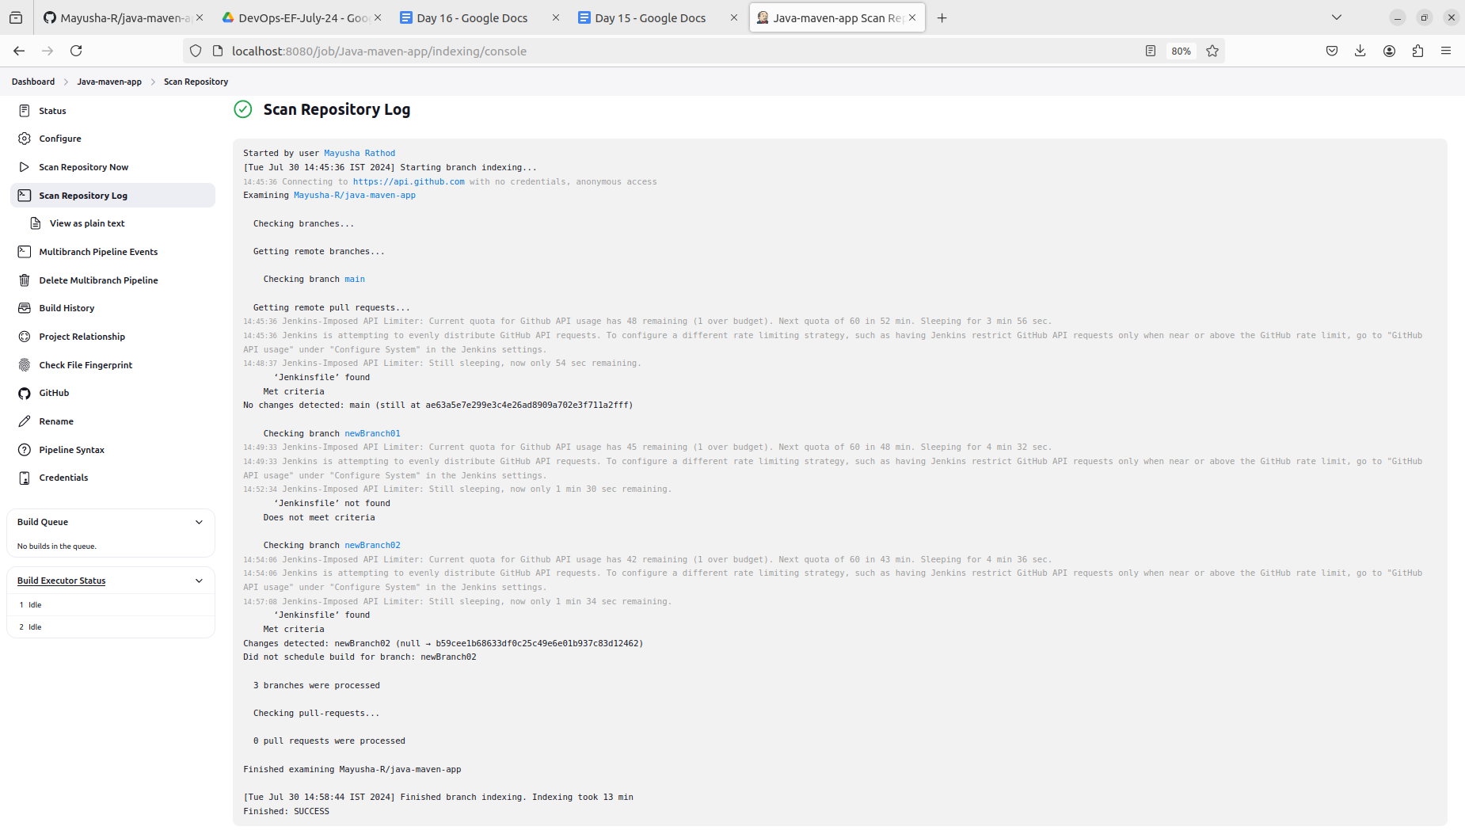

Configuration for above output:

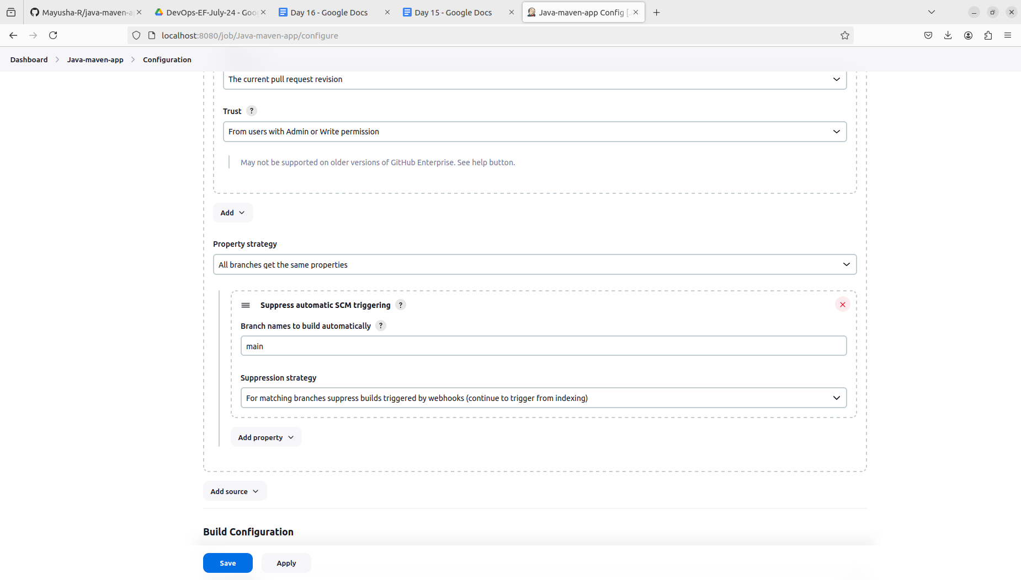

Different configuration:

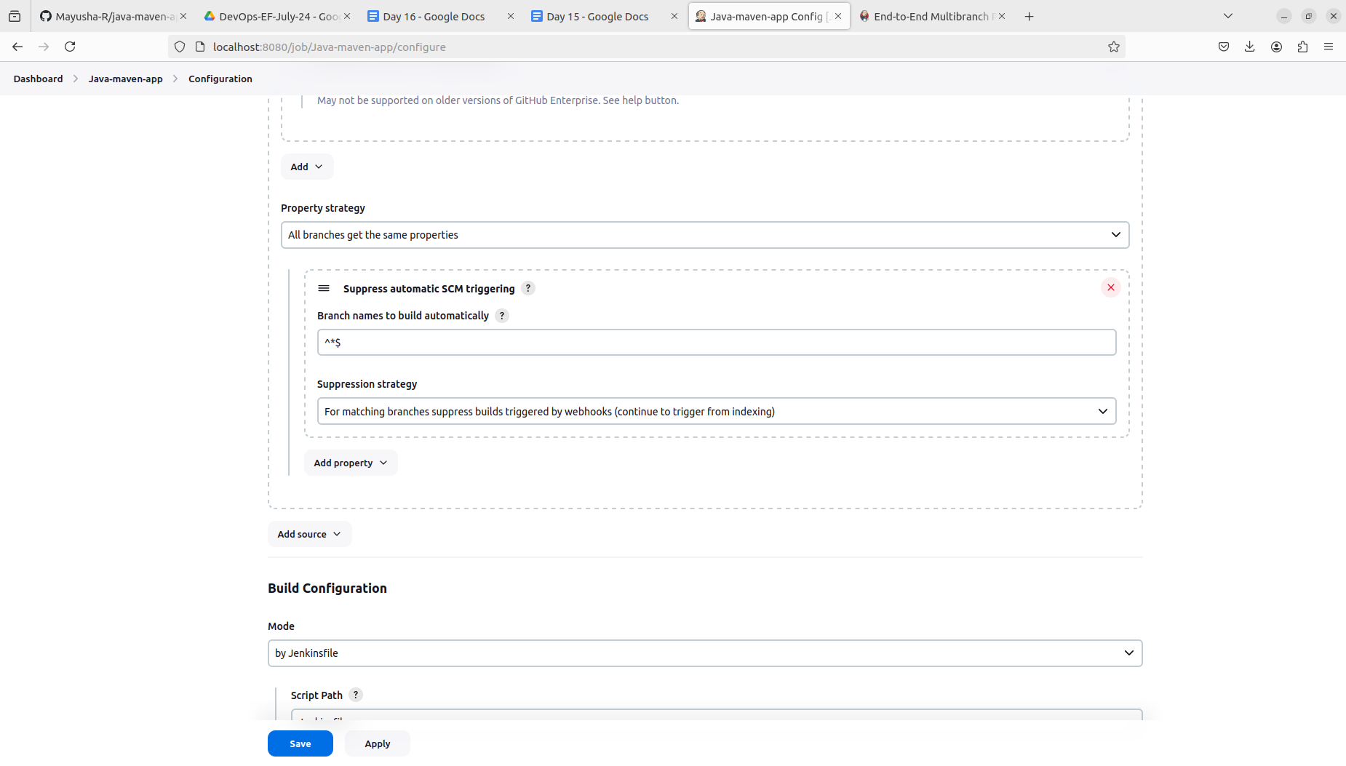

Output:

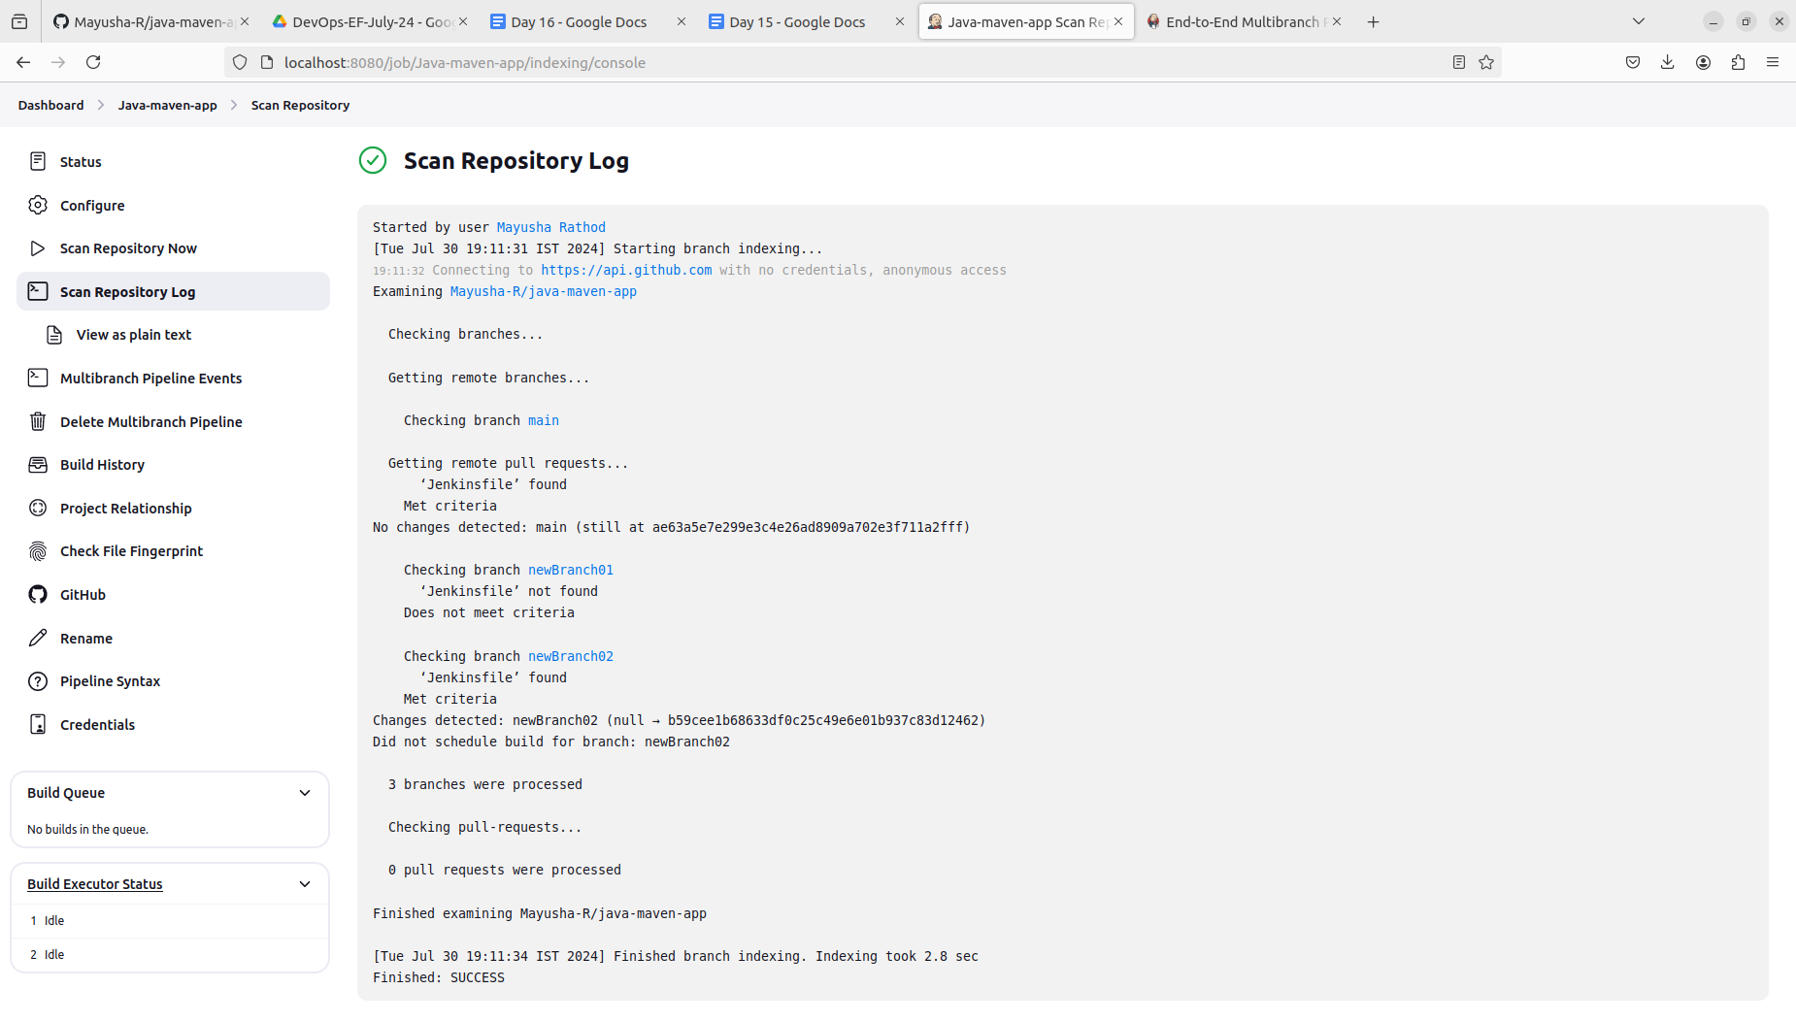

Branches build:

